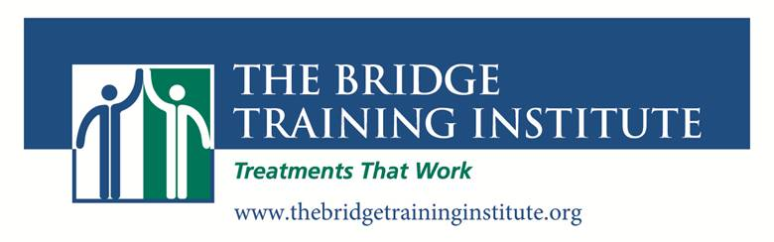
2016 – 2017 Training Calendar

The Clinical Experts Series

Friday, October 7, 2016, 9:00 AM – 4:00 PM
Motivational Interviewing: Making Real Change Possible
Harry Cunningham, LICSW

Friday, October 28, 2016
Understanding Gender Identity: Working with Transgender and Gender-Variant Youth
Sidney Trantham, Ph.D

Friday, November 4, 2016, 9:00 AM – 4:00 PM
Meeting the Challenge of Suicidal and Self Injurious Behaviors:
Updating Our Toolkit to Include the Most Current Theories and Interventions
Barent Walsh, Ph.D.

Friday, December 2, 2016, 9:00 AM – 4:00 PM
Building Teams in Difficult Circumstances:
Developing Communication, Collaboration and Collegiality
Dan Jacobs, Psy.D

Friday, December 9, 2016, 9:00 AM – 4:00 PM
Dialectical Behavior Therapy with Families
Jennifer Eaton, MS, LMHC, Marie-Paule de Valdivia LCSW

Friday, January 13, 2017, 9:00 AM – 4:00 PM
Introduction to Cognitive-Behavior Therapy:
Everything You Need To Know to Get Started In CBT
Peter Moran, Ph.D.

Friday, February, 10, 2017, 9:00 AM – 4:00 PM
Psychological First Aid: Your First Response to Traumatic Events
Larry Berkowitz, Ed.D, James McCauley, LICSW

Friday, March 10, 2017, 9:00 AM – 4:00 PM
Effecting Change in Multi-Stressed Families:
Addressing Transgenerational Substance Abuse and Mental Health Concerns
Dan Jacobs, Psy.D

Friday, March 17, 2017, 9:00 AM – 4:00 PM
Solution Focused Therapy: Creating Hope and Possibilities
Ann Bodmer Lutz, M.D.

Friday, April 7, 2017, 9:00 AM – 4:00 PM
Mindfulness with Children and Teens:
Proven interventions in every treatment setting
Christopher Willard, Ph.D.

Friday, May 5, 2017, 9:00 AM – 4:00 PM
Problematic Sexual Behavior in Children and Adolescents: A Developmental Perspective
Craig Latham, Ph.D.
2016 – 2017
The Dialectical Behavior Therapy Series
With Jennifer Eaton, LMHC

DBT Skills Training

Friday, November 18, 2016, 9:00 AM—4:00 PM
DBT Skills Part 1: The biosocial theory, orientation to DBT skills and individual therapy, treatment hierarchy, structuring therapy, the Core Mindfulness skills

Friday, December 16, 2016, 9:00 AM—4:00 PM
DBT Skills Part 2: DBT groups, structuring and running skills groups, leader/co-leader roles, the Distress Tolerance Skills

Friday, January 27, 2017, 9:00 AM—4:00 PM
DBT Skills Part 3: Skills practice, DBT homework groups, Behavior Management in a group setting, the Emotion Regulation Skills

Friday, February 17, 2017, 9:00 AM—4:00 PM
DBT Skills Part 4: Skills coaching, validation, DBT specialty skills, the Interpersonal Effectiveness skills

DBT Individual Therapy

Friday, March 24, 2017, 9:00 AM—4:00 PM
DBT Individual Therapy Part 1: Structuring the therapy, pretreatment, behavior assessment, chain analysis,

Friday, April 14, 2017, 9:00 AM—4:00 PM
DBT Individual Therapy Part 2: Dialectical strategies, communication strategies, insight & didactic strategies, relationship strategies, therapy interfering behaviors

Friday, May 19, 2017, 9:00 AM—4:00 PM
DBT Individual Therapy Part 3: The suicide assessment protocol, coaching calls by individual therapist & milieu coaching, crisis strategies, hospital strategies

Friday, June 2, 2017, 9:00 AM—4:00 PM
DBT Individual Therapy Part 4: Cognitive modification, exposure techniques, case management strategies, secondary targets, and the consultation team

